

Installation Guide for Beginners

Manjaro 0.8.2

The Manjaro Development Team

Core Team
Roland Singer - Project Leader, Designer, Developer, Web Developer, Packager
Guillaume Benoit - Server Manager, Packager, Moderation
Philip Müller - Mirrors Manager, Packager, Developer, Web Developer

Website and Artwork Team
Tillman Ebert - Web Developer, Web Consultant, Designer
Wlad Meixner - Web Developer, Web Consultant

Forum, Community and Support
Allesandro Calo - Community, Forum, Website
Carl Duff - Community, Wiki, Documentation

Contents Page

Introduction 4

1. Installation Overview 5
2. Setting Your Language and Keyboard Layout 5
3. Starting the Stable Installer 7
4. Setting the Date and Time 8
5. Preparing the Hard Disk 10
6. Installing Manjaro 14
7. Configuring Manjaro 16
7.1 Root Password 16
7.2 User Account 17
7.3 Set Locale (optional) 18
7.4 Set Keymap (optional) 19
7.5 Exit the Configuration Menu 21
8. Installing the Bootloader 22
9. Completing the Installation 24

Useful Links 25

Introduction

About Manjaro

Manjaro is a user-friendly Linux distribution based on the independently developed Arch operating system. Within the Linux community, Arch itself is renowned for being an exceptionally fast, powerful, and lightweight distribution that provides access to the very latest cutting edge - and bleeding edge - software. However, Arch is also aimed at more experienced or technically-minded users. As such, it is generally considered to be beyond the reach of those who lack the technical expertise (or persistence) required to use it.

Developed in Austria, France, and Germany, Manjaro provides all the benefits of the Arch operating system combined with a focus on user-friendliness and accessibility. Available in both 32 and 64 bit versions, Manjaro is suitable for newcomers as well as experienced Linux users. For newcomers, a user-friendly installer is provided, and the system itself is designed to work fully 'straight out of the box' with features including:
- a pre-installed desktop environment
- pre-installed graphical applications to easily install software and update your system
- pre-installed codecs to play multimedia files, and
- a suite of pre-installed popular applications such as Skype, Firefox, and Libre Office.

Features
Manjaro shares many of the same features as Arch, including:
- Speed, power, and efficiency
- Access to the very latest cutting and bleeding edge software
- A 'rolling release' development model that provides the most up-to-date system possible without the need to install new versions
- Access to the Arch User Repositories, and
- The versatility to be shaped and moulded in every respect to suit personal taste and preference.
However, Manjaro boasts a few extra features of its own, including:
- A simplifed, user-friendly installation process
- Automatic detection of your computer's hardware (e.g. graphics cards)
- Automatic installation of the necessary software (e.g. graphics drivers) for your system
- Dedicated software repositories for the delivery of fully tested and stable software packages, and
- Support for the easy installation and use of multiple kernels

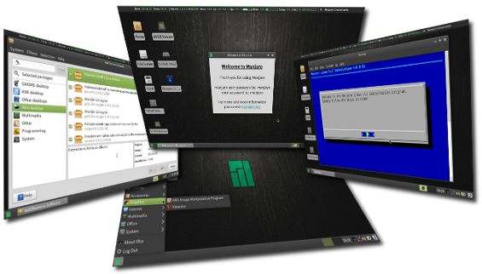

1. Installation Overview

Tip: If possible, ensure that you are connected to the internet prior to booting from your installation media (e.g. disc, USB flash drive, or even an ISO file directly if booting in Oracle's Virtualbox). If you have a hard-wired connection via an ethernet cable, then Manjaro will automatically connect to the internet without you having to do anything. Otherwise, once you have booted into Manjaro's desktop, you will need to select and then connect to your wireless network.
This Beginners' Guide is suitable for those with limited technical knowledge and experience. In this instance, it will not be necessary to manually partition your computer's hard disk or to manually edit various configuration files. However, using this guide will result in the complete erasure of your hard disk during the installation process. Manjaro will be installed alone. You will also not be able to configure Manjaro to support the use of multiple languages, although this feature can still be enabled after installation, if you wish.

2. Setting Your Language and Keyboard Layout

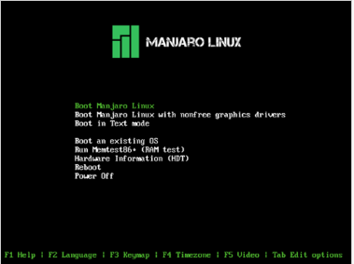
Once Manjaro has started, you should be presented with the Manjaro boot screen. However, don't actually boot into anything just yet! First it will be necessary to set your preferred language and keyboard layout. While the benefits of using your main language and keyboard layout for the installation process itself may be obvious, setting these now will also make configuring your installed system much faster and easier, too.
Don't worry if your preferred language or keyboard layout isn't listed, as a far wider range of languages can be selected during the installation process itself, if necessary.

Tip: Setting the language and keyboard layout - as shown below - are undertaken through pressing the Function (F) keys. As many computers have multiple functions assigned to each function key, it may be necessary to hold down another key first to use them. For example, on a HP G62 laptop, to use the function keys, the 'fn' key must first be pressed and held.

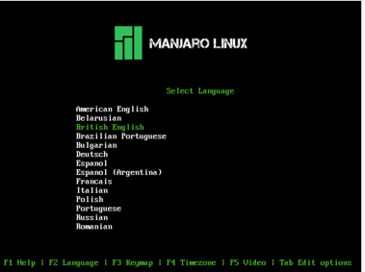
First, set your preferred language by pressing the F2 key.
The options available can be highlighted for selection by using the up or down arrow keys on your keyboard. In this instance, British English has been highlighted for the user.
Tip: Keep scrolling down past 'Romanian' to see a few extra languages that are supported.
Once selected, press <enter> to confirm and to be taken back to the boot menu.

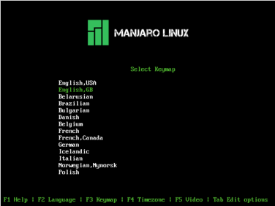
Second, set your preferred keyboard layout (keymap) by pressing the F3 key.
Again, the options available can be highlighted for selection by using the up or down arrow keys on your keyboard. In this instance, English GB (Great Britain) has been highlighted for the user.
Tip: Again, not all supported languages may be initially shown on the list.
Once selected, press <enter> to confirm and be taken back to the boot menu.

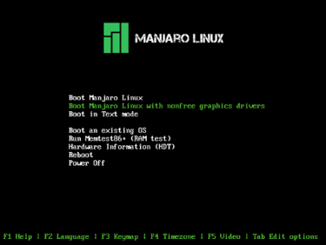
Manjaro can now be booted to begin the installation process. Two options are available:
1. Boot Manjaro Linux
2. Boot Manjaro Linux with non-free graphics drivers
Tip: For the best results, select the 'Boot Manjaro Linux with non-free graphics drivers'. This should match the right manufacturer's driver(s) your particular graphics card(s).
Again, use the arrow keys to highlight your choice, and then press <enter> to continue.

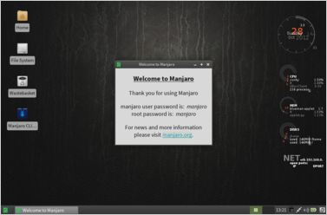
As seen here, Manjaro 0.8.2 with the XFCE desktop environment is to be installed. However, irrespective of the Manjaro flavour (i.e. desktop environment) you have chosen to install, the installation process itself will still be the same.
Tip: If you wish to connect to the internet using a wireless connection, now is the time to do it!
To begin the installation process, close the welcome window, and then double-click the "Manjaro CLI Installer" icon.

3. Starting the Stable Installer

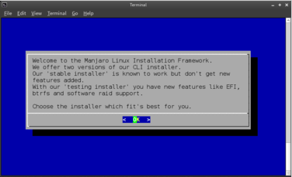
The installer will begin by stating that there are two installation versions available: The Stable Installer and the Testing Installer. This guide will use the Stable Installer.
Press <enter> to continue.

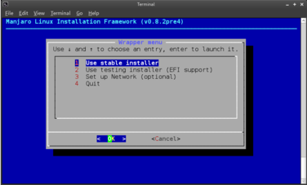
Select the stable installer.
This option should already be highlighted. If not, use the arrow keys to highlight it.
Press <enter> to continue.

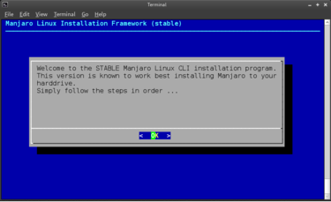
A confirmation message will appear, stating that the Stable installer has begun. It also provides some good advice: Follow the steps IN ORDER.
Press <enter> to continue.

4. Setting the Date and Time

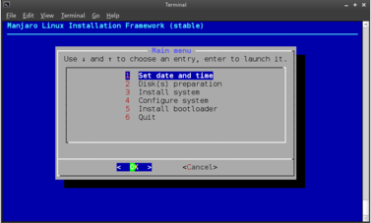
Set Date and Time should already be highlighted. If not use your arrow keys to do so.
Press <enter> to continue.

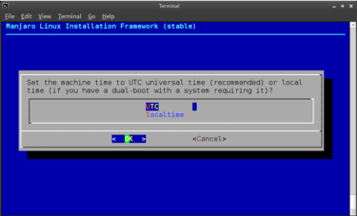
Ensure that UTC (Co-ordinated Universal Time - the primary time standard by which the world regulates its clocks and times) is highlighted.
Press <enter> to continue.

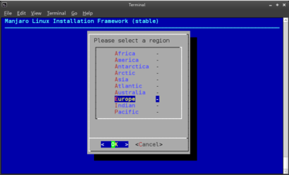
Highlight the region you live in.
In this instance, Europe has been chosen, as this is the region applicable to Great Britain.
Press <enter> to continue.

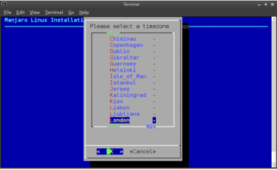
Select your time zone.
This is understaken by highlighting the appropriate capital city.
Tip: As there are a lot of cities to chose from, you can skip forwards in the menu by entering the first letter of the appropriate city to be taken to that section.
Press <enter> to continue.

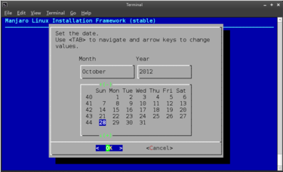
Set the date.
If you are already connected to the internet, then this should already be set for you. Otherwise, use the <tab> key to switch between the day, month, and year elements, and use the up or down arrow keys to change them.
Ensure that OK is highlighted, and press <enter> to continue.

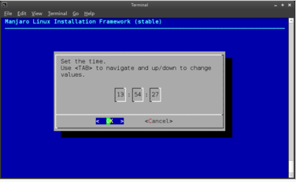
Finally, set the time.
Again, if you are already connected to the internet, then this should already be set for you. Otherwise, use the <tab> key to switch between the hours, minutes, and seconds elements, and use the up or down arrow keys to change them.
Ensure that OK is highlighted, and press <enter> to be taken back to the main installation menu.

5. Preparing the Hard Disk

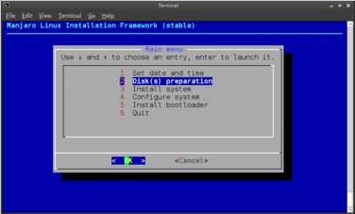
Prepare your computer's hard disk for installation.
Again, in this tutorial the assisted preparation method will be chosen, which is most suitable for beginners.
Ensure that Disk(s) Preparation is highlighted.
Press <enter> to continue.

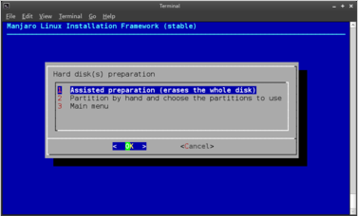
Ensure that Assisted Preparation (erases the whole disk) is highlighted.
As the option would suggest, this will erase your entire hard disk. Make sure you have backed your files up somewhere (e.g. disc, USB flash drive, internet, etc.).
Press <enter> to continue.

Note: The space to be set aside on your hard disk for each step of this stage is measured in megabytes (MB). It is also important to keep in mind how much hard disk space you have remaining for each step. In this tutorial, the total hard disk space being used is 40,960MB (40 gigabytes / GB).

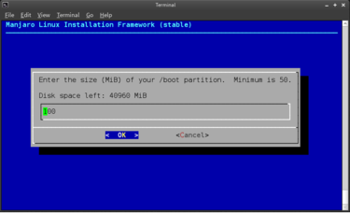
Set the amount of hard disk space for the GRUB (GRand Unified Bootloader).
This is responsible for booting up Manjaro after your computer is turned on. The default value of 100MB is more than sufficient.
Press <enter> to continue.

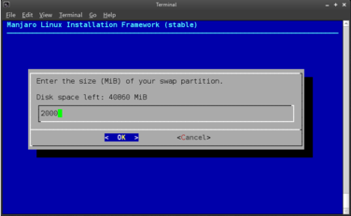
Set the amount of hard disk space for the Swap Partition. Should your computer run out of memory (RAM) while it is being used, the hard drive can be used to compensate as a form of virtual RAM. This is what the Swap Partition is for.
The size of the Swap Partition should be equal to the amount of memory (RAM) used by your computer . For example, 2000MB (2GB) of Swap should be set for a computer using 2GB of RAM. Once set, press <enter> to continue.

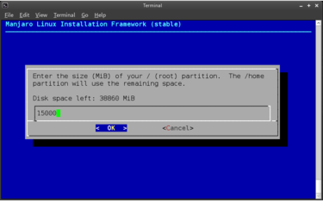
Set the amount of hard disk space for the Root Partition. This is where Manjaro and its installed applications will be stored.
Where possible, it is recommended to set the value of the Root Partition to at least 15,000MB (15GB). Just ensure that this leaves plenty of space for your Home Partition, which which where all your personal files will be stored.
Once you have set the size of your Root Partition, press <enter> to continue.

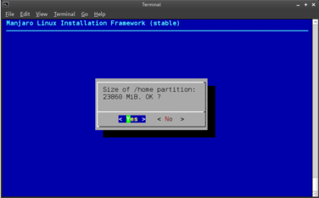
Confirm the amount of hard disk space for the Home Partition. 15GB of 38GB hard-disk space has already been allocated to the Root partition, so the remaining 23,860MB (23GB) has been automatically allocated to the Home partition. Again, the Home partition is where all your personal files will be stored.
If you are not happy with the amount of space allocated, highlight No and press <enter> to go back. Otherwise, ensure that Yes is highlighted.
Press <enter> to continue.

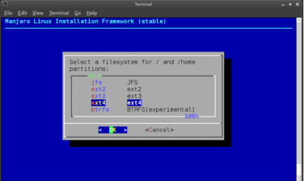
Set the file system to manage your files.
Different file systems can handle different file sizes, numbers of files, and so on. If you are unsure which file system to choose, as illustrated, it is recommend that you highlight ext4 as this is one of the latest and perhaps most widely used Linux file systems.
Press <enter> to continue

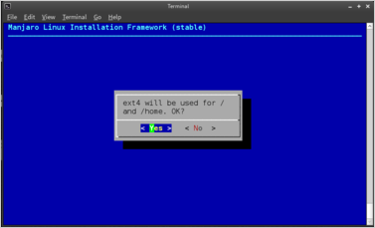
Confirm your selected file system.
If you wish to review or perhaps change your selection, highlight No and press <enter> to be taken back to the list of available file systems. Otherwise, ensure that Yes is highlighted.
Press <enter> to continue.

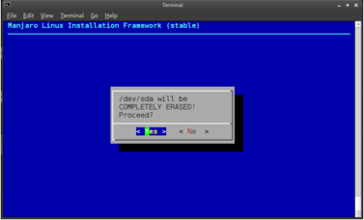
Confirm that you wish to proceed with the assisted preparation.
A warning will now appear that proceeding will result in your hard disk (referred to as /dev/sda) being completely erased. If you do not wish to continue, highlight No and press <enter> to be taken back to the hard disk preparation menu. Otherwise, ensure that Yes is highlighted.
Press <enter> to continue.

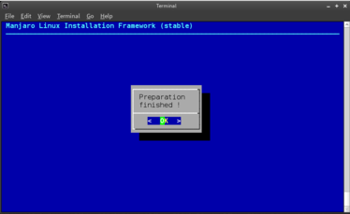
The installer will take a few moments to set up your hard disk (and in the process, completely erase any data that was previously stored on it). Once complete, the illustrated confirmation message will appear.
Press <enter> to confirm and to be taken back to the hard disk preparation menu.

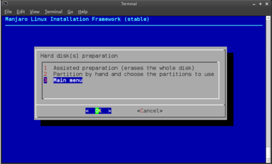
Go back to the Main Menu.

As this step has been completed, highlight Main menu and press <enter> to be taken back to the installer's main menu.

6. Installing Manjaro

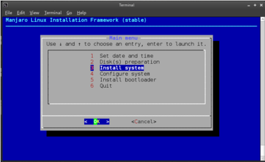
Ensure that Install System is highlighted.
Press <enter> to continue.

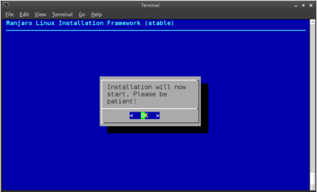
Start the Installation. A message will appear stating that the installation process is about to begin.
Press <enter> to continue.

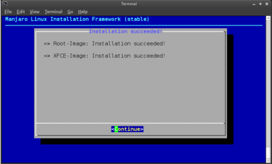
After a few moments, a message will appear confirming Manjaro has been successfully installed.
Press <enter> to continue.

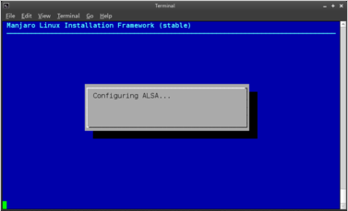
The installer will now automatically configure your system, detect your hardware, and install the appropriate drivers. It will also find the Manjaro servers from which you can download updates, software packages, and applications. This process may take a minute or two.
Warning: Manjaro will not be able to find the available servers unless you are connected to the internet.
Once complete, you will automatically be returned back to the installer's Main menu.

7. Configuring Manjaro

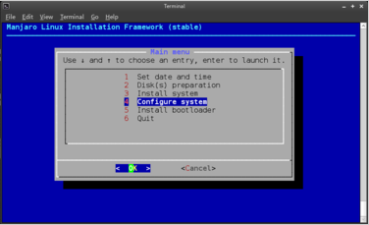
It will now be necessary to personalise Manjaro by configuring a few key things. Don't worry about this as there will be no need for any technical expertise or to manually edit any configuration files. The process will be quick and painless!
Ensure that Configure System is highlighted.
Press <enter> to continue.

7.1 Root Password
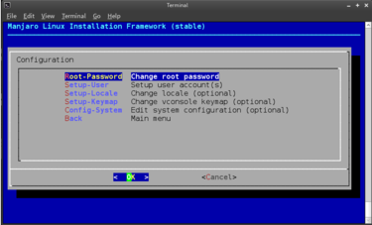
Set the Root password. In a nutshell, Root is a standard user account included in Linux distributions by default that has full and unrestricted access to the system. A Root account is necessary to have in order to install, change, and remove system files.
Ensure that Change Root Password is highlighted.
Press <enter> to continue.

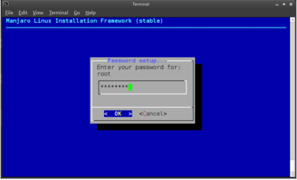
Type in your chosen Root password. You can enter just about anything you like.
Tip: Passwords will be case sensitive. To use the password later on, the upper and lower case letters will have to match exactly. Oh, and use a password you'll be able to remember!
Once complete, ensuring that OK is highlighted, press <enter> to continue. You will then have to re-enter the Root password again to confirm it. Once again, ensure that OK is highlighted.
Press <enter> to continue.

7.2 User Account
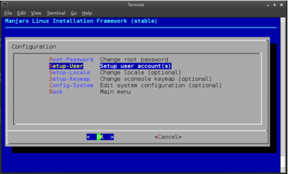
Set up your own personal user account.
To protect the system, you will not be expected to use the system as a Root user at all times. As such, you should also create your own personal account.
Ensure that Setup user account(s) is highlighted.
Press <enter> to continue.

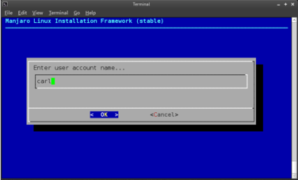
Type in your chosen account / login name. The default name is manjaro, which can be changed by deleting it and replacing it with your own. In this instance, the username carl has been entered.
Warning: Although you can enter almost anything you like, ensure that any and all letters in the name are in lower case.
When finished, ensure that OK is highlighted.
Press <enter> to continue.

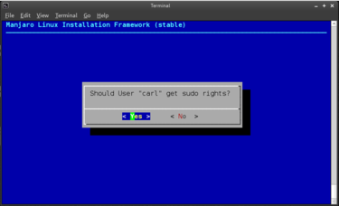
Confirm that you wish to get sudo rights.
Sudo is short for 'Super User Do', and means that your own account will be granted the same system privileges as the Root account.
However, undertaking such tasks using your personal account will require you to enter your password to continue, which will be set up next.
Ensure that Yes is highlighted, and Press <enter> to continue.

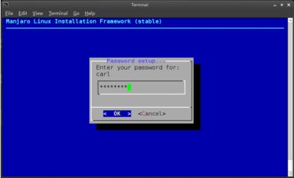
Type in your chosen password for your own personal account. Again, you can enter just about anything you like.
Tip: To keep things simple, you can just type the same password used for the Root account.
Once complete, ensuring that OK is highlighted, press <enter> to continue. You will then have to re-enter your password again to confirm it. Once again, ensure that OK is highlighted.
Press <enter> to continue.

7.3 Set Locale (optional)
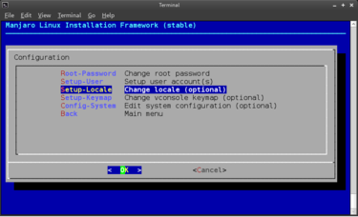
Set your preferred language.
If you were able to set your preferred language at the beginning, then you can skip this step.
Otherwise, ensure that Change locale (optional) is highlighted.
Press <enter> to continue.

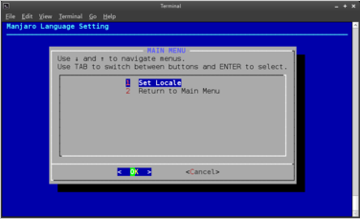
Confirm that you wish to set your preferred language by ensuring that Set Locale is highlighted.
Press <enter> to continue.

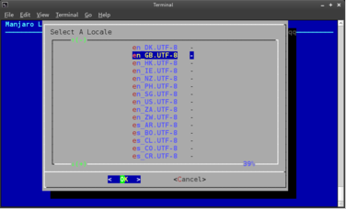
A list of codes will be presented that begin with two lower case letters, followed by two UPPER CASE letters. The lower case letters stand for the language, and the upper case letters stand for the country: language_COUNTRY.
For example, en_GB stands for English, Great Britain. The UTF-8 and ISO parts of each line are used by the system. Try to pick a code that ends in UTF-8 if possible.
Once you have highlighted your desired code, press <enter> to set it.
Tip: If you are not sure what code represents your language and country, a small selection of examples are available here: http://www.fincher.org/Utilities/CountryLanguageList.shtml (ignore the use of dashes '-'instead of underscores '_').

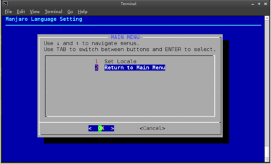
Return to the configuration menu my highlighting Return to Main Menu.
Press <enter> to continue.

7.4 Set Keymap (optional)
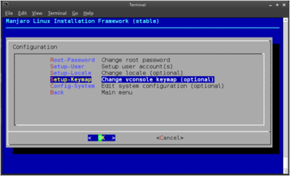
Set your preferred keyboard layout.
If you were able to set your preferred keyboard layout at the beginning, then you can skip this step.
Otherwise, ensure that Change vconsole keymap (optional) is highlighted.
Press <enter> to continue.

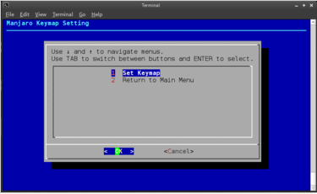
Confirm that you wish to set your preferred language by ensuring that Set Keymap is highlighted.
Press <enter> to continue.

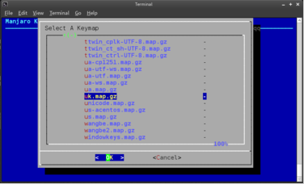
A list of codes will be presented, representing the various different keyboard layouts available. If you do not know the necessary code for your keyboard layout, then it may be necessary to undertake a Google search to determine this. In this instance, for illustrative purposes, the code uk.map.gz has been selected, as this is the appropriate code for the keyboard layout used in the United Kingdom / Great Britain.
Once you have highlighted your desired code, press <enter> to set it and be taken back to the keymap menu.

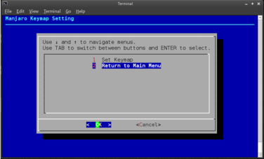
Return to the configuration menu by highlighting Return to Main Menu.
Press <enter> to continue.

7.5 Exit the Configuration Menu
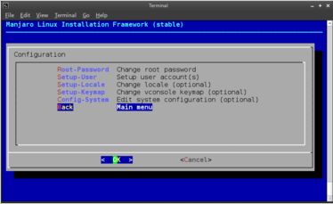
With the configuration complete, exit from the configuration menu by highlighting Main Menu.
Press <enter> to continue.

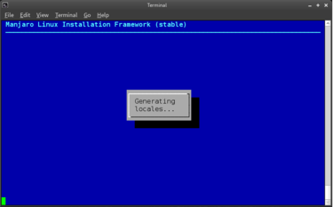
It will then be necessary to wait a few moments while the Manjaro installation is automatically configured according to your preferences. Once complete, you will automatically be taken back to the Main Menu.

8. Installing the Bootloader

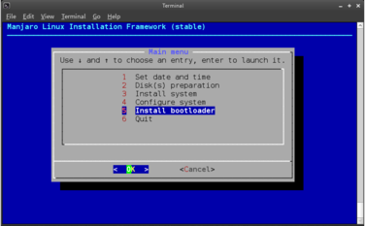
Finally, install the GRUB.
Again, the GRUB (GRand Unified Bootloader) is responsible for booting up (i.e. starting) Manjaro when you turn your computer on.
Ensure that Install Bootloader is highlighted.
Press <enter> to continue.

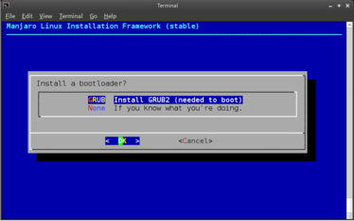
Ensure that Install GRUB2 (needed to boot) is highlighted.
Press <enter> to continue.

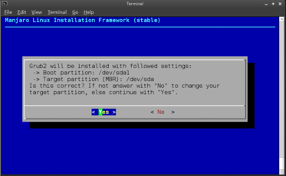
A confirmation message will appear, stating the target partition (place on your hard disk) where GRUB2 is to be installed. The default setting is fine.
Press <enter> to start the installation.

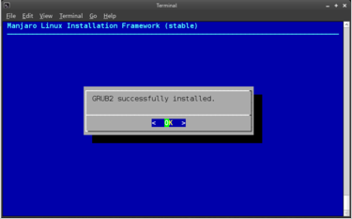
A confirmation message will appear after a few seconds, stating that GRUB2 has been successfully installed.
Press <enter> to be taken back to the main installer menu.

9. Completing the Installation

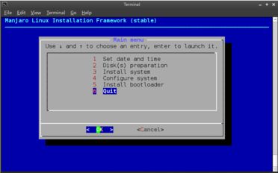
All done - now highlight Quit to finish the installation!
Press <enter> to continue.
The installer will then take a few moments to finalise the installation. A confirmation message will then appear, stating that the installation process has finished. The installer will then automatically close, and you will be returned to the desktop environment.

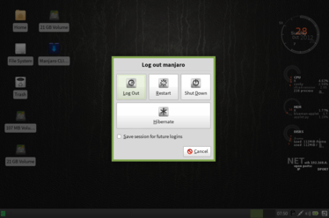
You can now reboot your computer to start your newly installed Manjaro operating system!

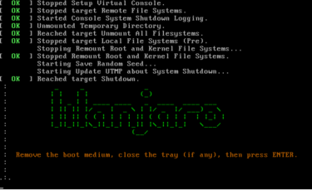
During the reboot (or shut-down) you will be reminded to remove your installation media before pressing <enter> to continue. If you don't do this, you'll end up booting right back into the installation media again.
Tip: The first thing you should do upon booting up into Manjaro is to update your system using the pacman-gui application, available from the System section of your desktop menu.

Useful Links

Manjaro Homepage
For the latest news, developments, download links, contact details, and more.
http://blog.manjaro.org/

Manjaro Forum
Read and participate in our active form – everybody's welcome!
http://forum.manjaro.org/index.php

Manjaro Wiki
Beginner-friendly guides are available to help you use the system and to solve problems.
http://wiki.manjaro.org/index.php/Main_Page

